MOUNT KENYA UNIVERSITY
School of Computing & Information Technology
Course Code: BIT 4102 – Computer Graphics
Practical CAT Documentation
Title: Architectural Design of a 14-Floor Commercial Building

GROUP MEMBERS
1. LOISEROSE NJERI WAINAINA BIT/2025/69955
2. CLIFF MUNENE MAINA BIT/2025/30005
⁠3. MERVEILLE LWANZO BIT/2025/69906
4.YVONNE WANGECI WANGUI BIT/2025/43219
5.NANCY SARANGE BIT/2025/32683
6. NEWTON KARIITHI BIT/2025/31318
7.Chris Musila BIT/2024/59761
8. Felister Mopeyian BIT/2025/69147
9.Jacob
10.Brian mumo BIT/2025/30082
11.BIT/2025/30054-DORINE WANJIRU WAMBUI

1. Introduction
This documentation presents the complete design and drafting process of a 14-floor commercial building developed using ArchiCAD as required
The project demonstrates:
- Application of architectural drafting standards
- Proper use of layers and line types
- Accurate scaling and dimensioning
- Application of symbols and legends
- Technical presentation professionalism
The drawings were created following architectural conventions and computer graphics principles to ensure clarity, precision, and professional presentation.

2. Software and File Preparation
2.1 Software Used
- ArchiCAD (.pln)
- PDF Export Tool
2.2 GitHub Submission
The editable file was uploaded to GitHub and the repository link submitted through the portal.

3. (a) Building Floor Plan Design (10 Marks)
3.1 Overview
A typical floor plan was designed to represent one floor of the 14-storey commercial building. The design ensures functional office distribution, proper circulation, safety compliance, and vertical transport systems.

3.2 Architectural Components Included
1. Structural Elements
- External walls (thicker line weight)
- Internal partition walls
- Columns
2. Circulation
- Main corridor (minimum 1.5m width)
- Emergency staircase
- Elevator shafts
3. Rooms and Functional Spaces
- Individual offices
- Open office workspace
- Conference room
- Washrooms (Male/Female)
- Utility/storage room

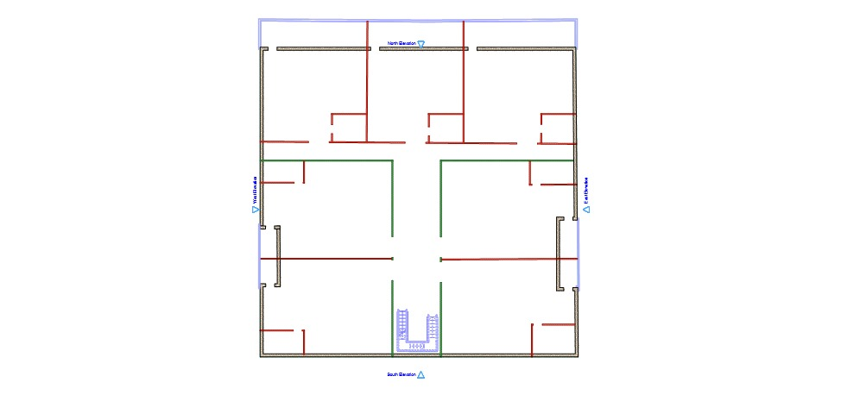

3.3 Use of Layers
The following layer structure was used:
Layer Name | Purpose | Line Type
WALL_EXT | External walls | Continuous
WALL_INT | Internal walls | Continuous
DOORS | Doors | Continuous
WINDOWS | Windows | Continuous
STAIRS | Staircases | Continuous
ELEVATOR | Lift shafts | Continuous
DIMENSIONS | All dimensions | Continuous
TEXT | Labels | Continuous
Proper layer color coding was applied for clarity.

3.4 Dimensions and Labels
- All rooms were dimensioned in meters
- Door and window sizes were clearly indicated
- Rooms were labeled (e.g., OFFICE 1, CONFERENCE ROOM, WC MALE)
- Floor scale: 1:100

4. (b) Electrical Wiring Layout
4.1 Design Overview
The electrical layout was designed following standard electrical drafting principles.
It includes:
- Main power supply entry point
- Distribution board (DB)
- Lighting circuits
- Socket outlets
- Switch positions

4.2 Electrical Components Shown
- Ceiling light points
- Power sockets
- Switches near doors
- Main distribution panel
- Emergency lighting near staircases
Standard electrical symbols were used and explained in a legend.
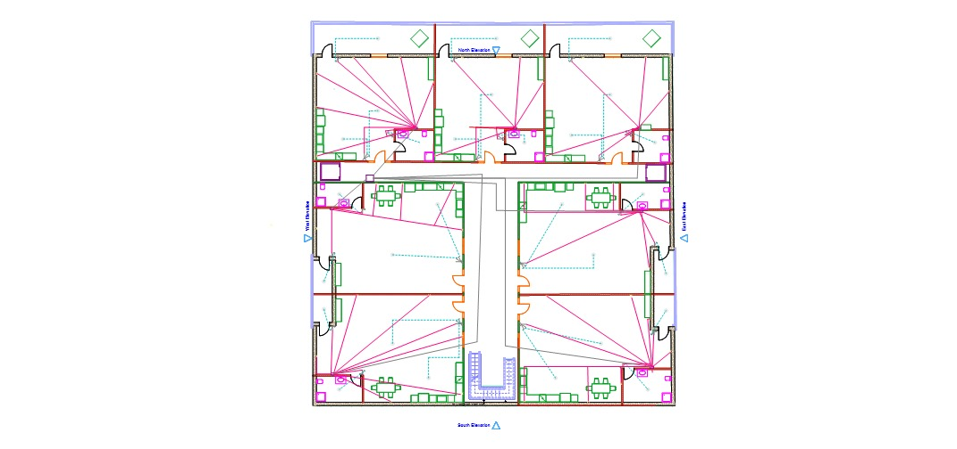

4.3 Legends and Symbols
A legend box was created indicating:
- Light symbol
- Switch symbol
- Socket symbol
- Distribution board symbol

5. (c) Water Supply and Plumbing Plan
5.1 System Overview
The plumbing system was designed to serve all washrooms vertically across 14 floors using risers.

5.2 Components Included
- Main water inlet at ground floor
- Overhead water tank
- Vertical risers
- Horizontal branch pipes
- Washroom plumbing connections
- Drainage pipes
Pipe routing was done neatly avoiding structural interference.

5.3 Plumbing Symbols Used
- Cold water pipe
- Hot water pipe
- Drain pipe
- Water tank
- Pump room
All symbols were included in a plumbing legend.

6. (d) Wi-Fi and Network Cabling Plan
6.1 Network Design Overview
The building network was designed using a structured cabling system.
Each floor includes:
- One distribution switch
- Multiple Wi-Fi access points
- Data sockets in offices
- Backbone vertical cable

6.2 Network Components
- Server room (Ground Floor)
- Backbone fiber cable
- Floor distribution switch
- Ethernet cabling routes
- Wireless access points (centrally placed)

6.3 Labeling
- All switches labeled (SW-F1, SW-F2 etc.)
- Access points labeled (AP-1, AP-2)
- Backbone clearly marked

8. Computer Graphics Principles Applied
This project demonstrates the following graphics principles:
- Precision and coordinate accuracy
- Layer-based object management
- Scaling and proportion
- Symbol abstraction
- Visual clarity and readability

9. Challenges Encountered and Solutions
Challenge | Solution
Layer confusion | Created structured naming convention
Overlapping electrical lines | Used different colors and line weights
Pipe routing complexity | Used vertical risers for alignment
Scaling issues | Verified drawing units before dimensioning

10. Conclusion
The 14-floor commercial building design was successfully created using ArchiCAD while strictly following the instructions provided.
The project demonstrates:
- Strong understanding of architectural drafting
- Proper application of computer graphics techniques
- Professional presentation standards
- Technical accuracy and organization
All files were saved in the correct format, exported to PDF, uploaded to GitHub, and submitted as required.

REFERENCES
American National Standards Institute. (2017). Architectural drawing standards and symbols. ANSI.
Autodesk. (2023). AutoCAD user guide. https://www.autodesk.com
Ching, F. D. K. (2014). Architectural graphics (6th ed.). John Wiley & Sons.
International Organization for Standardization. (2015). ISO 128-20: Technical drawings — General principles of presentation. ISO.
National Fire Protection Association. (2020). National electrical code (NFPA 70). NFPA.
Tanenbaum, A. S., & Wetherall, D. J. (2011). Computer networks (5th ed.). Pearson Education.
Kenya Bureau of Standards. (2018). Building construction standards. KEBS

